**Database Systems and File Structures**

**Project 1**

**README File**

By- Arya, Shubham

Sapkota, Bishwamitra

Shrestha, Yugal

For this project, we used MySQL Workbench. Through MySQL Workbench, we created tables, loaded data into the tables, and wrote SQL queries to get the desired result.

**CREATING TABLE**

To create a table, locate ‘*Tables*’ on the schema. Right click on ‘*Tables*’ and a menu with an option ‘*Create Table…*’ will show up. Click on that and the below screens would appear. Enter the name of the table on the top text field next to ‘*Name*’. To add an attribute, click on *‘<click to edit>*’ and fill out the column, datatype, and check the constraints needed. When all the attributes and their constraints are added, click on ‘*Apply*’ to create this table.

EMPLOYEES table-

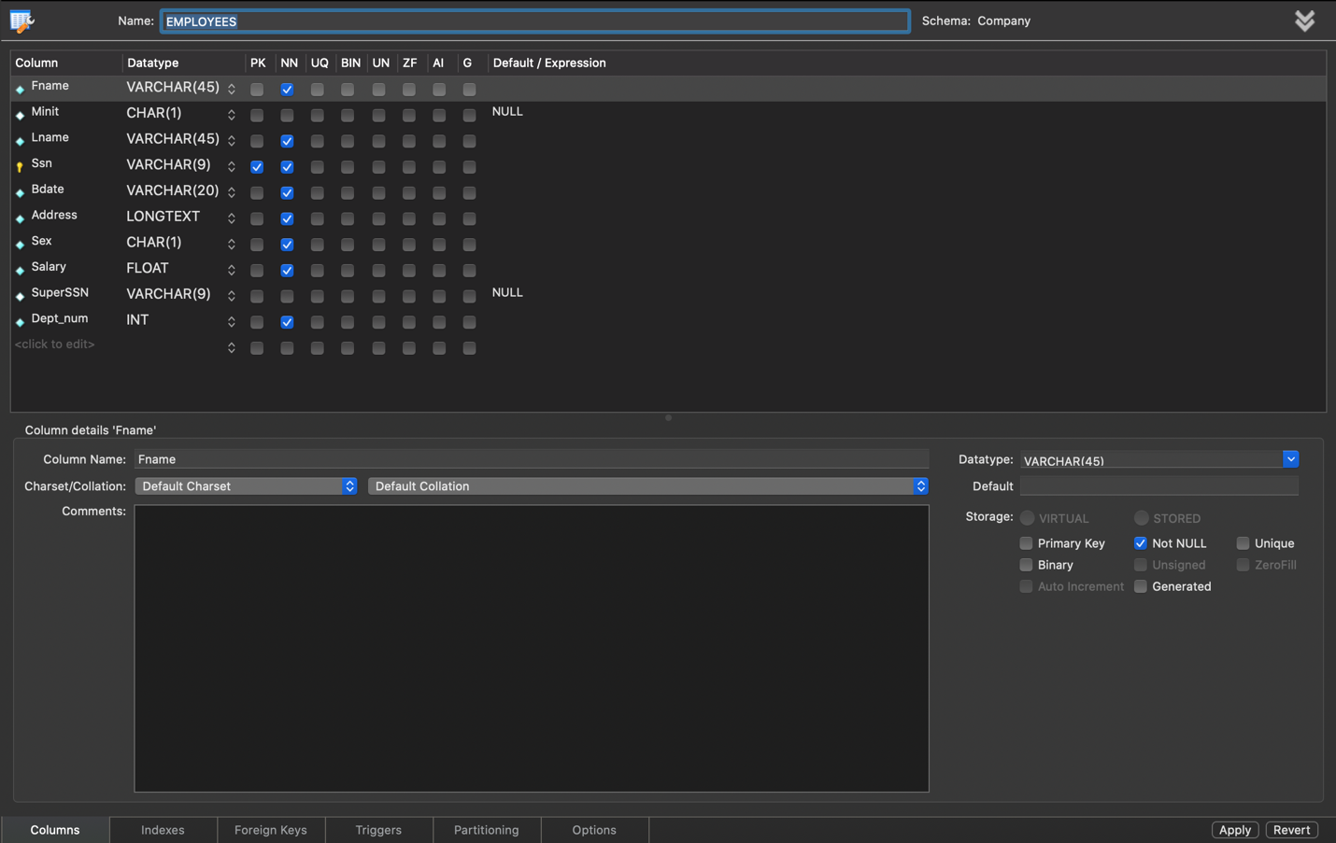

DEPARTMENT table-

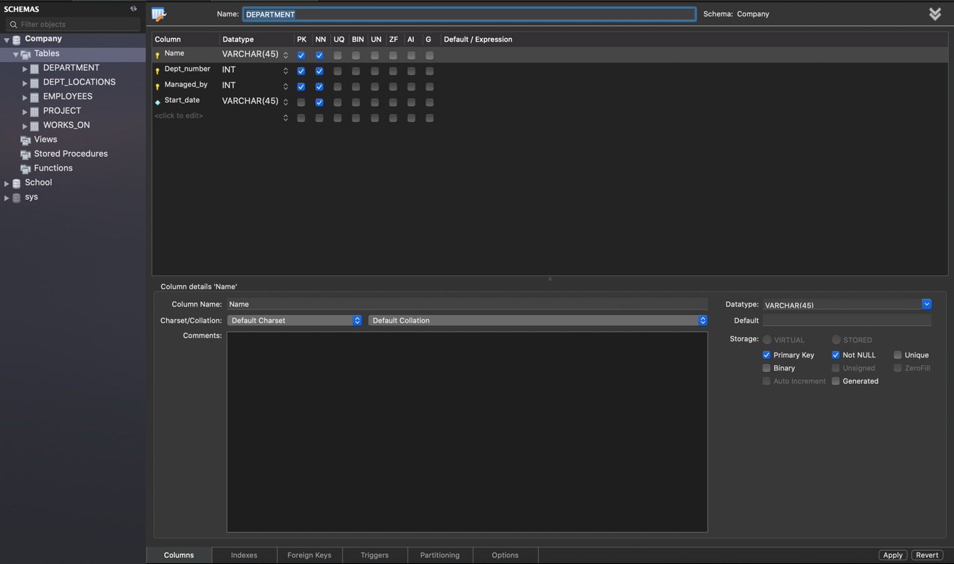

PROJECT table-

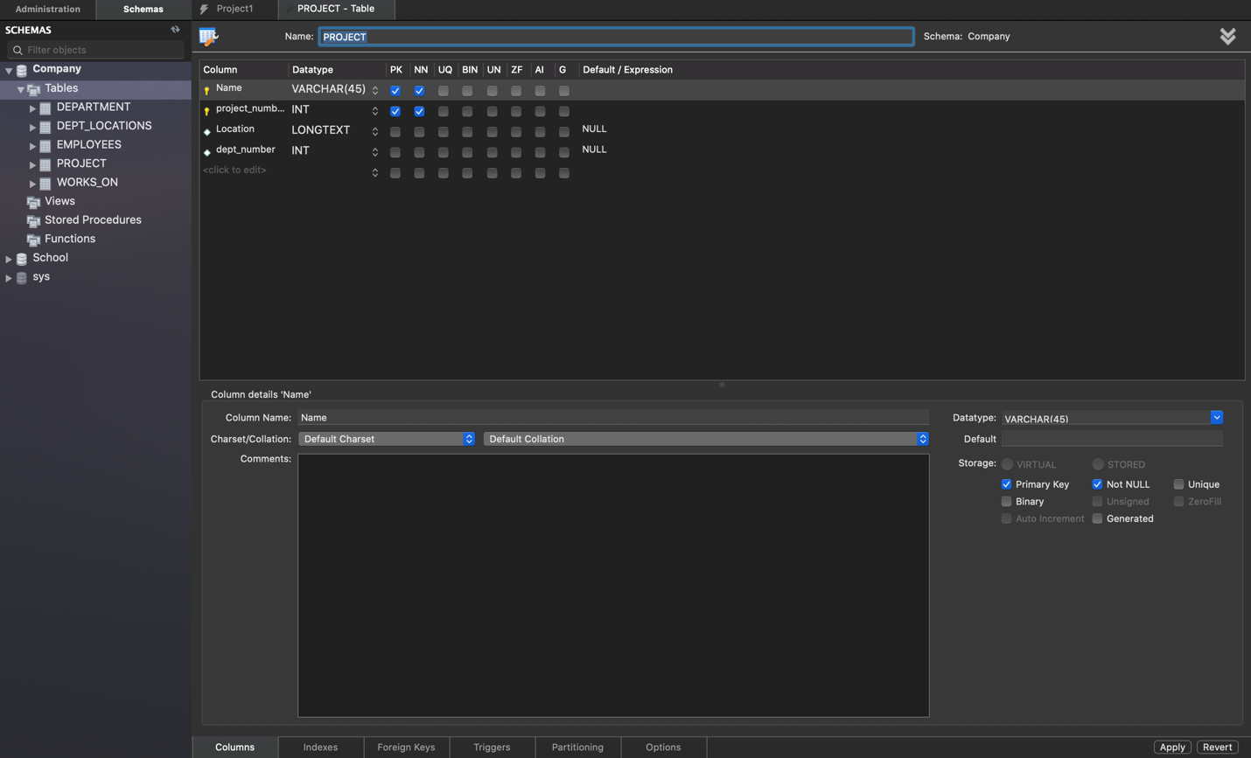

WORKS_ON table-

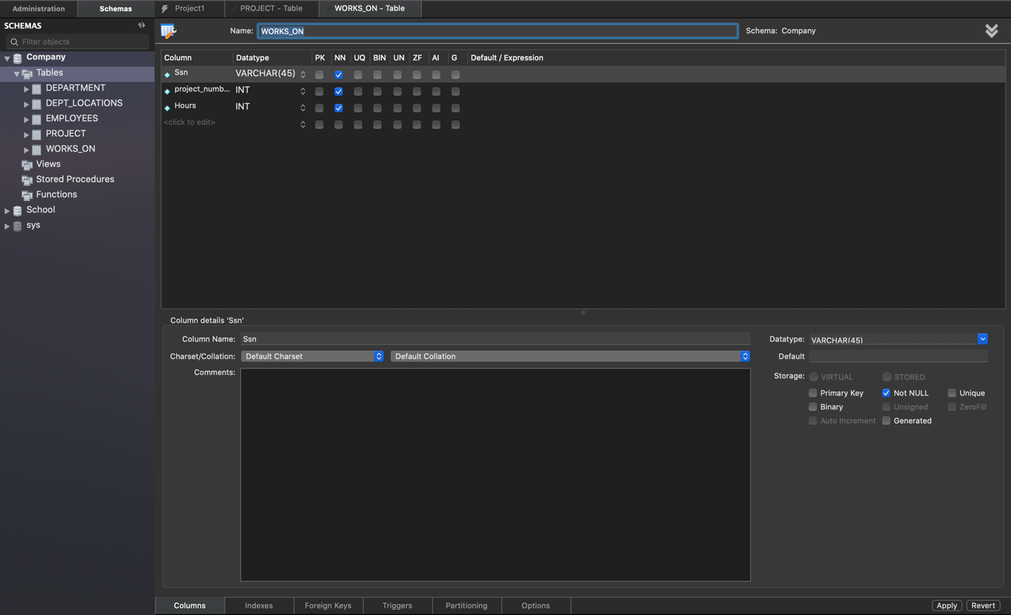

DEPT_LOCATIONS table-

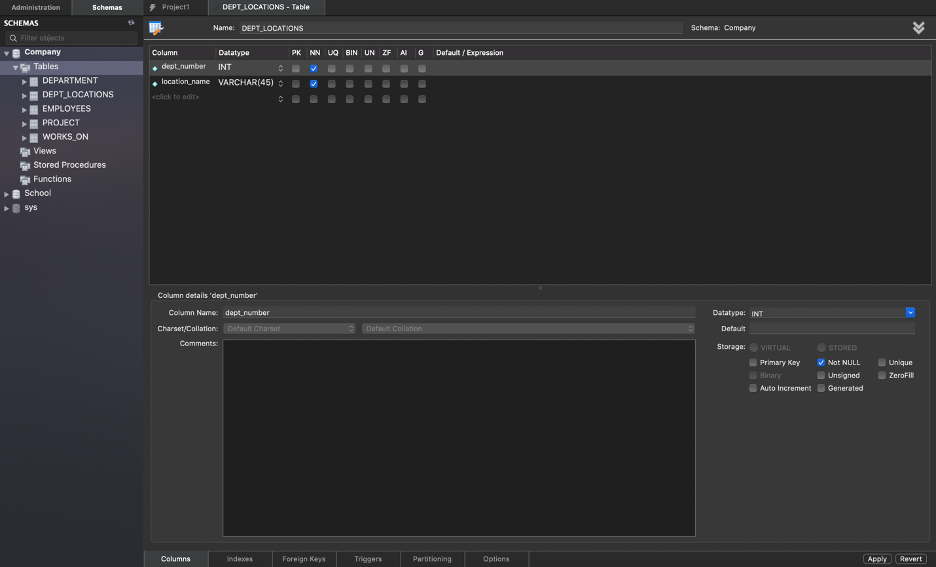

**Loading Tables**

We used the following lines to load data into all the required tables from the entry files provided to us.

**INSERT INTO table_name**

**VALUES (attribute11, attribute12, …, attribute1n),**

**(attribute21, attribute22, …, attribute2n),**

**.**

**.**

**.**

**(attributem1, attributem2, …, attributemn);**

Here are some tables that were created using the above code.

Loading data in EMPLOYEES table-

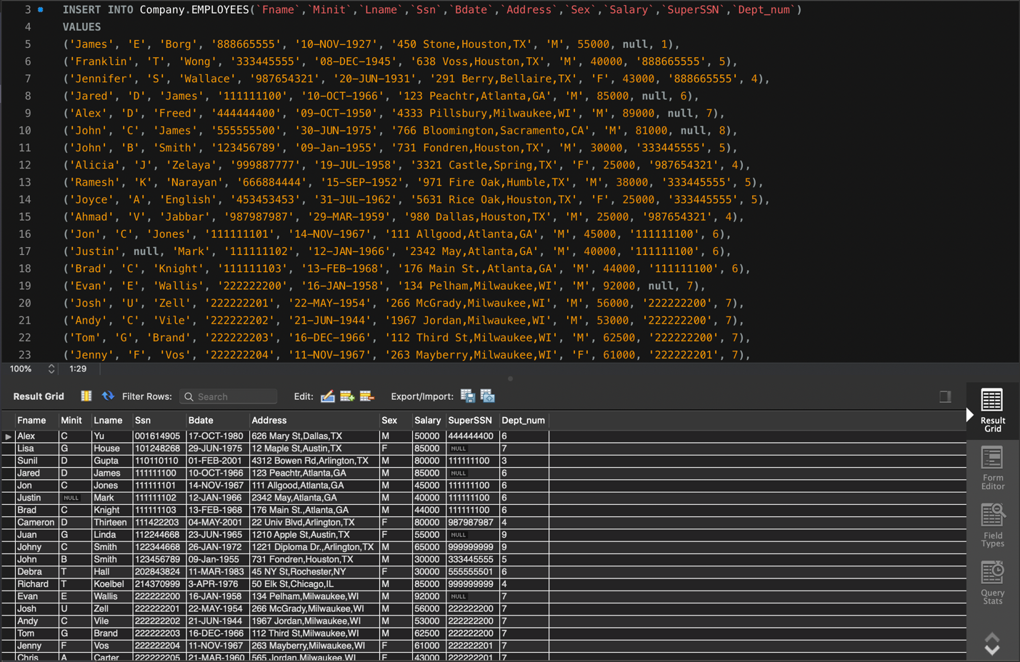

Loading data in DEPARTMENT table- 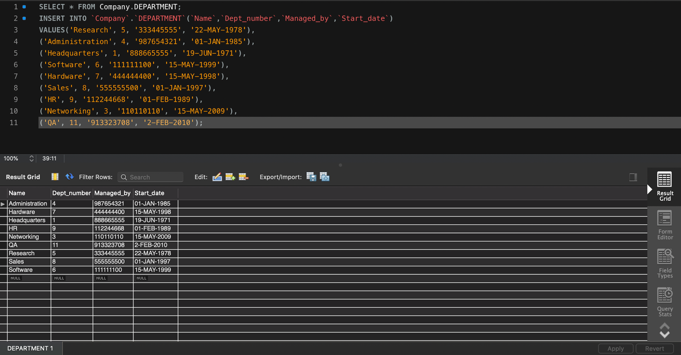

Loading data in PROJECT table-

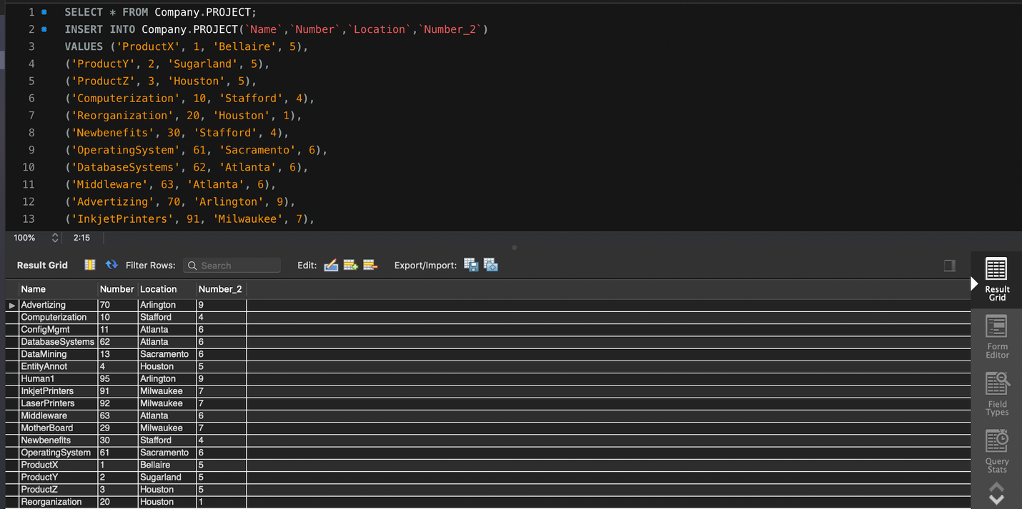

Loading Data in WORKS_ON table-

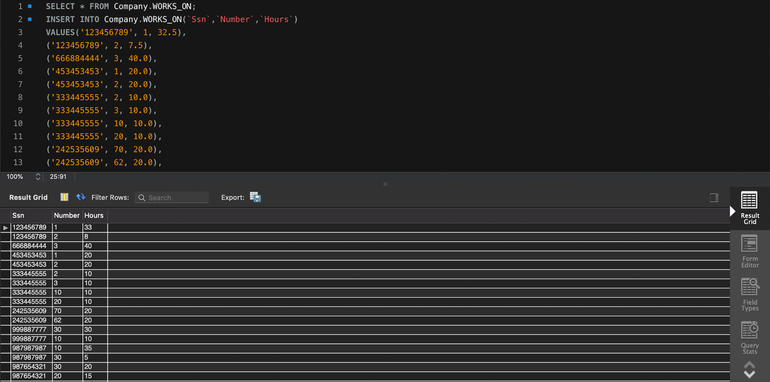

Loading data in DEPT_LOCATIONS table- 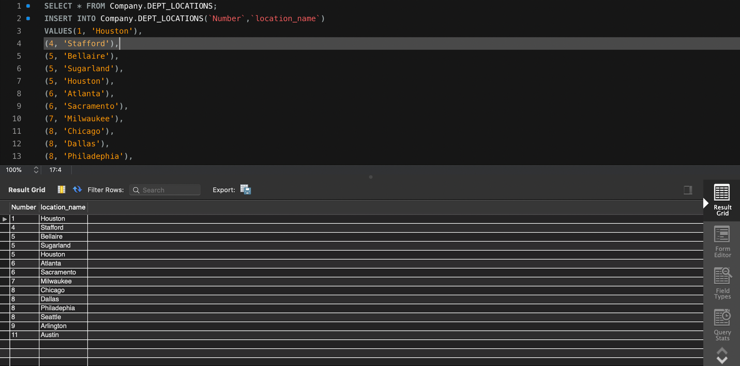

We also used LOAD DATA method to load the tables. Below are the screenshots for this.

Loading EMPLOYEES table

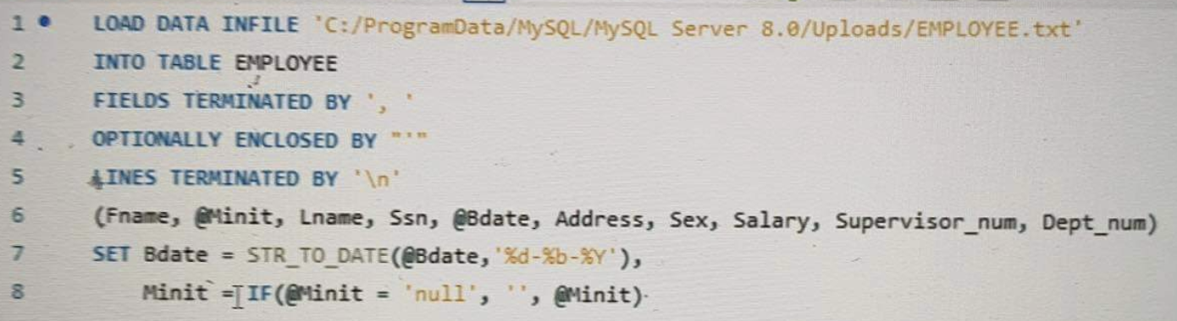

Loading DEPARTMENT table

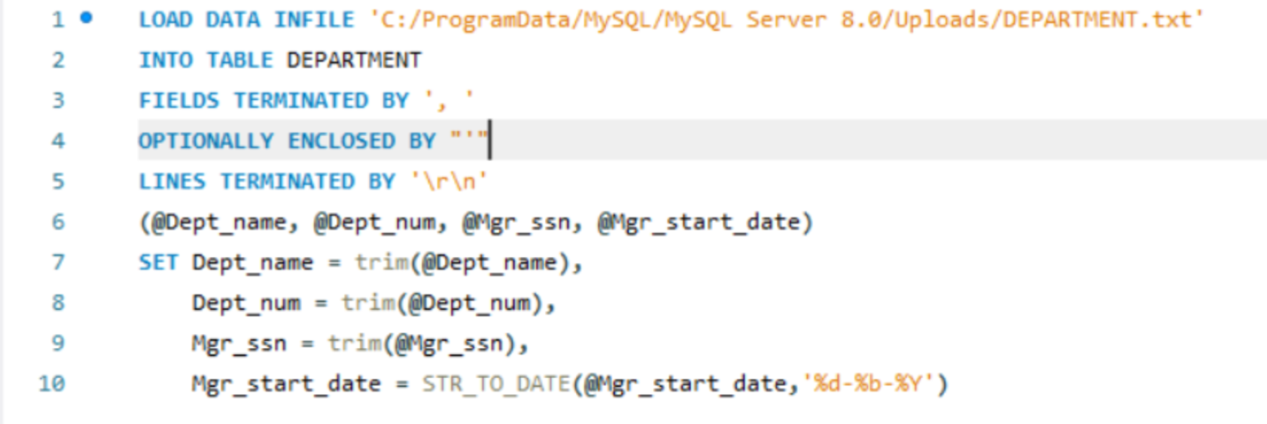

Loading WORKS_ON table

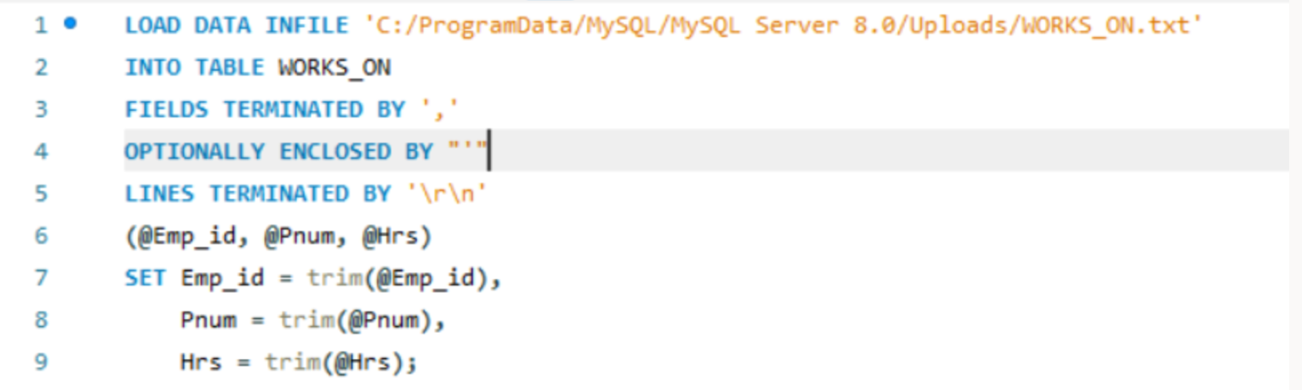

Loading PROJECT table

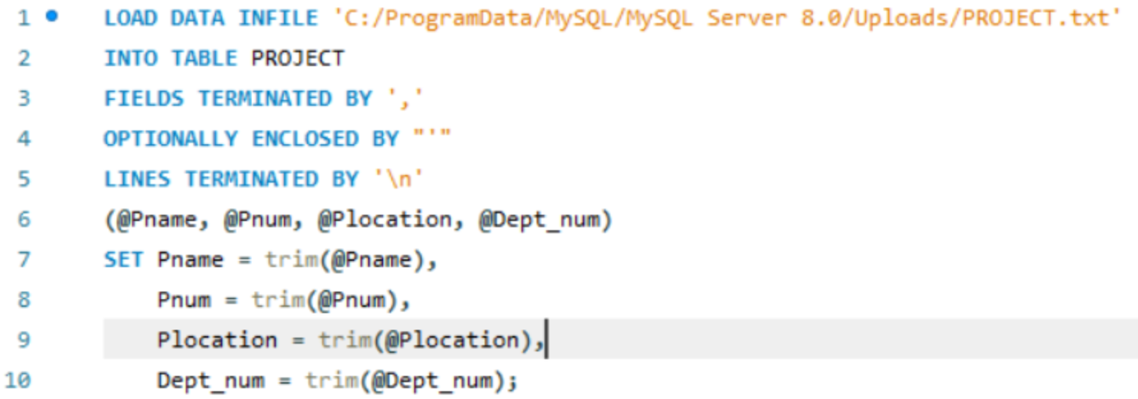

Loading DEPT_LOCATIONS

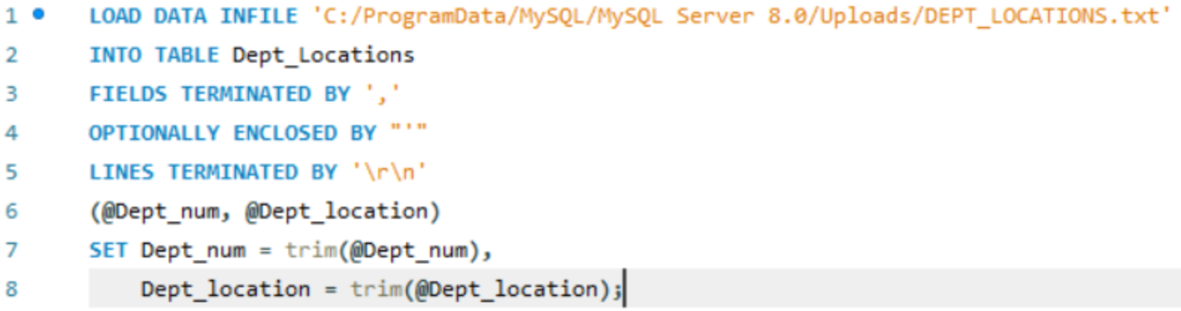

**Source code**

1. Enter a department name and retrieve all the names and salaries of all employees who work in that department.

Query-

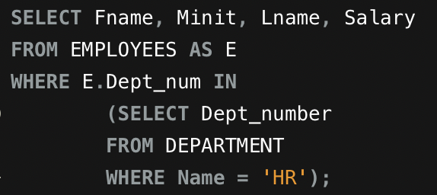

Output-

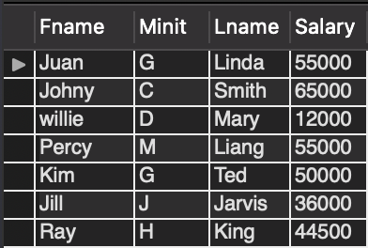

2.Enter an employee last name and first name and retrieve a list of projects names/hours per week that the employee works on.

Query-

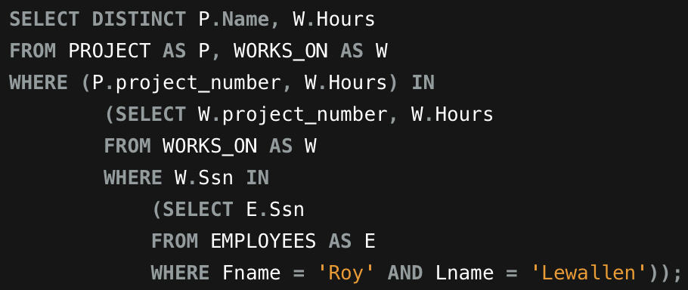

Output-

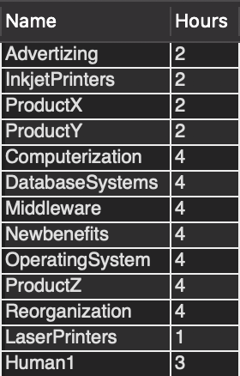

3. Enter a department name and retrieve the total of all employee salaries who work in the department.

Query-

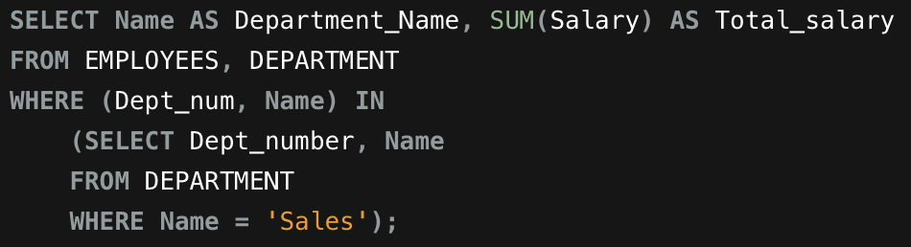

Output-

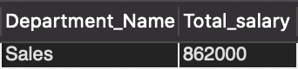

4. For each department, retrieve the department name and the number (count) of employees who work in that department. Order the result by number of employees in descending order.

Query-

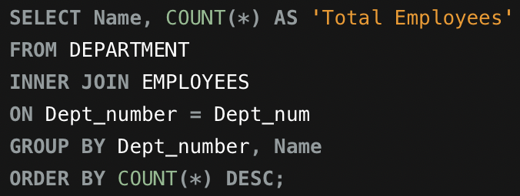

Output-

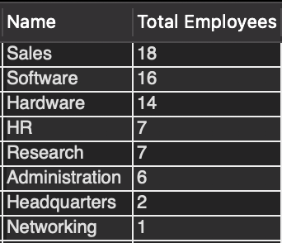

5. For each employee who is a supervisor, retrieve the employee first and last name and the number (count) of employees that are supervised. Order the result in descending order.

Query-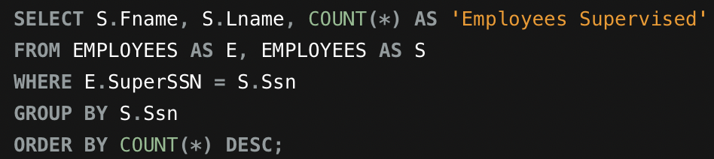

Output-

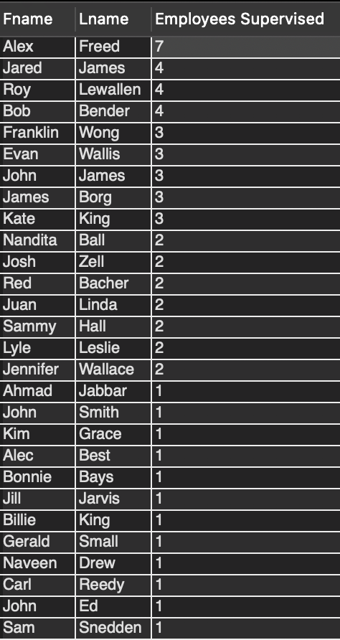

This project was done by Bishwamitra Sapkota, Shubham Arya and Yugal Shrestha. The work division by each person is given below.

Shubham Arya- Created the tables and loaded the data into the tables. Wrote the 5 queries and the README file.

Bishwamitra Sapkota – Created and loaded the tables with data. Wrote the last 3 queries and error proofed the README file.

Yugal Shrestha- Created and loaded the tables with data. Wrote the first 2 queries and error proofed all the queries